## Module 7 Student Questions

## Observation Experiments: Spin Echoes - Guided Inquiry Questions

Set up the [Bloch simulator](https://www.drcmr.dk/BlochSimulator/) to use ‘Inhomogeneity’ (an option in the ‘Equilibrium’ menu) so that we will see multiple spins responding to an inhomogeneous external magnetic field. We can leave relaxation off for now to make any echo appear more obvious. Let’s hop into the rotating frame (set frame to ‘B0’) to help clarify what we see.

1. After setting up the simulator as described above, knock down the spins with a hard-90°x pulse and draw a sketch and write a description of what you see. Add some arrows to your sketch showing which spins are precessing clockwise and which are precessing counterclockwise in the rotating frame. Recalling how we set up the simulation, what is causing the spins to dephase from each other? What relaxation time would characterize the resulting MR signal decay?
2. Start the spins at equilibrium again (by clicking on ‘Inhomogeneity’), knock down the spins with a hard-90°x pulse, and after some time, apply a 180°y pulse. Draw a sketch and write a description of what you see after the 180°y pulse is applied. Keep track of the direction of the spins precession in the rotating frame before and after the 180°y pulse. Does the direction of each individual spin’s precession change with the pulse? Does this make sense, considering the direction of the external magnetic field has not changed?
3. It is helpful to have a physical model in your head to make sense of the spin dynamics on the Bloch sphere that lead to spin echoes - some favorites are racers on a race track or opening/closing a folding fan. Choose your favorite physical model and explain what causes the echo you observe, in your own words.
4. Does the phase of the pulses (that is, whether they are applied in the x- or y- direction) appear to determine whether you see an echo or not? Apply different combinations of pulses on the simulator and your physical model to settle on your answer.
5. If the time between the 90° and 180° pulses is [](https://www.codecogs.com/eqnedit.php?latex=%5Ctau#0), how long after the 180° pulse do you expect to see the peak of the echo? Use the simulator and your physical model to settle on your answer.

## Hahn Echo Theory - Guided Inquiry Questions

1. What relaxation time constant should the Hahn echo experiment enable you to measure?
2. Describe an experimental procedure that you could use to measure this relaxation time constant.

## Can We Find T2 Using a Single Experiment and More Pulses? - Guided Inquiry Questions

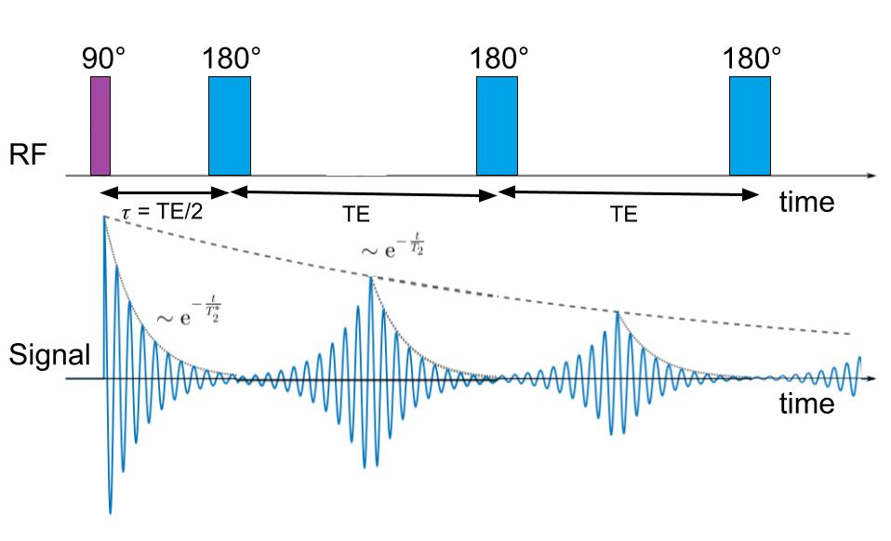

1. How does the CPMG pulse sequence compare with the experimental procedure you developed in the previous question?
2. TE is the shorthand for the 'echo time' or the time spacing between consecutive 180° pulses. Why does it make sense that the time between the initial 90° pulse and the first 180° pulse is TE/2?
3. What are some advantages to using the CPMG pulse sequence instead of just the standard Hahn echo pulse sequence to measure T2?
4. Describe how you would go about determining the T2 relaxation time constant for a sample if given data from a CPMG experiment.

## Reflection Questions

1. Below is some 1H CPMG data collected using a heavy mineral oil sample and very short echo times (TE). Estimate the TE time that is being used to collect this data. What parameter, |*Mxy*| or *Mx*, is being plotted along the y-axis?

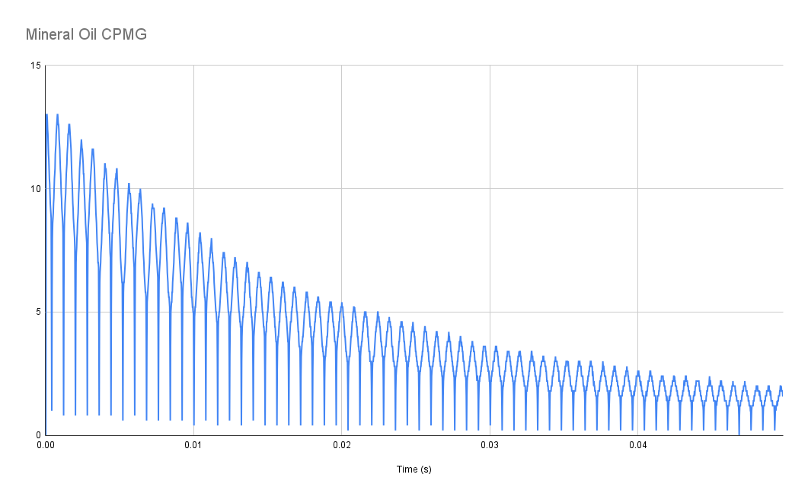

1. Below is some 1H CPMG data from a neoprene rubber sample using the same experimental settings as for the mineral oil sample above. Estimate the T2 relaxation time constant.

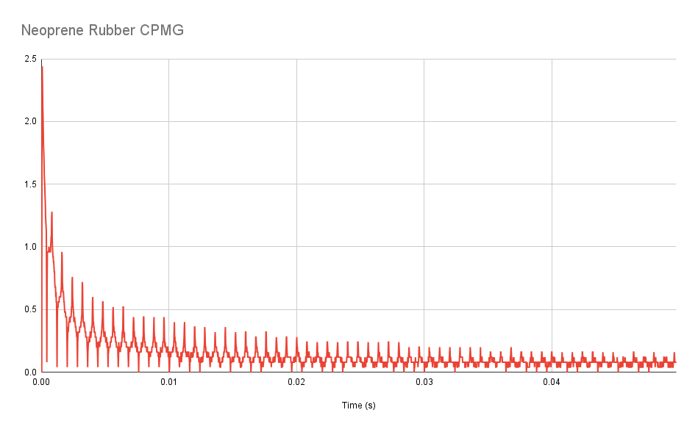

1. From the T2 time constants for the two samples above, what can you say about the local magnetic environment of neoprene rubber as compared with mineral oil (e.g., is it more or less homogeneous)?
2. Design an experiment that can test the hypothesis that the Hahn echo effectively gets rid of the effect of any external magnetic field inhomogeneities. Write a prediction of the results you would expect to see if you performed your experiment and this hypothesis was correct.

Below is a plot of the T2 curves for brain tissue compared with water. You should use this plot to answer the following questions.

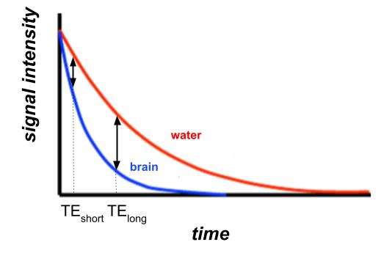

1. Which has the longer T2 time, brain tissue or water?
2. You are designing a T2-weighted MRI pulse sequence that needs to highlight any water in the brain. Looking at the T2 curves provided, which of the TE times (TEshort or TElong) would be a better choice? Why?

Read about what Hahn referred to as the "eight-ball echo": <https://www.mriquestions.com/90deg-90deg-hahn-echo.html> to help answer the following questions about the mysterious NMR signal below that was collected repeating an FID experiment with a short repetition (TR) time.

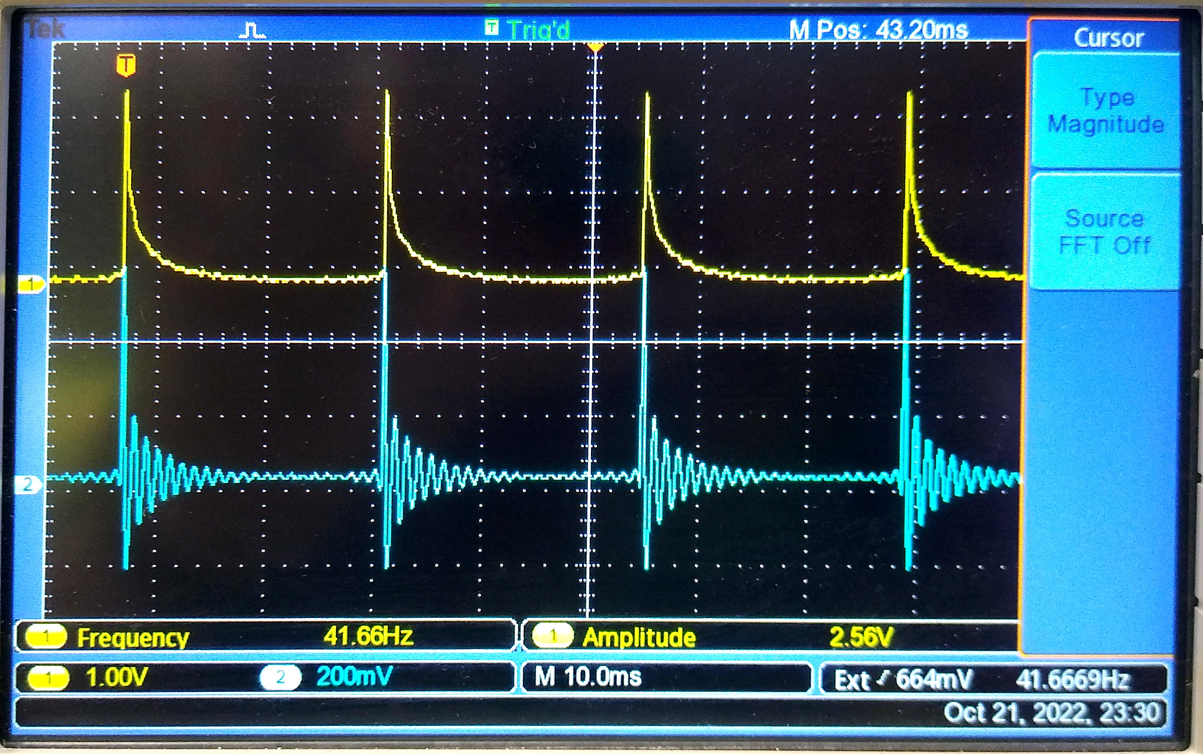

1. (Challenge Question) Using whichever representation or model you prefer, explain a possible source for the small signal we see right before each subsequent 90° pulse. Why does it make sense that it appears to peak at the time the next pulse occurs?
2. (Challenge Question) Provide a pulse sequence and an experimental procedure to test your hypothesis for the source of the signal.

## Follow this rubric to assess your work for this module:

| **Scientific Ability** | **Adequate** | **Needs improvement** | **Inadequate** | **Missing** |
| --- | --- | --- | --- | --- |
| **Is able to use the Bloch simulator and a physical model to answer questions about the spin dynamics resulting from a given pulse sequence** | The questions are correctly answered using both the Bloch simulator and a physical model. | The questions are correctly answered, but only using one of the two representations - Bloch simulator or physical model. | The questions are incorrectly answered or correctly answered without reference to either of the two representations. | No attempt is made to answer the questions. |
| **Is able to extract information from the provided NMR experimental data** | All necessary information has  been extracted correctly, and  written with correct units. | Some of the information is extracted  correctly, but not all of the  information. | Information that is extracted contains errors, such as labeling quantities incorrectly, not taking into account timescale or vertical scale information on plots, etc. | No visible attempt is made to extract information from the provided NMR experimental data. |
| **Is able to choose the correct experimental parameters to optimize**  **T2 contrast for different samples** | All experimental parameters to optimize T2 contrast for different samples are correctly identified. | Most of the experimental parameters to optimize T2 contrast for different samples are correctly identified. | An attempt is made, but most of the experimental parameters to optimize T2 contrast for different samples are incorrectly identified. | No attempt is made to identify the experimental parameters to optimize T2 contrast for different samples. |